**Individual Weekly Report**

**Name: Paul Bae**

**Team:** Good AIM

**Date:** Feb 24 2025

| **Current Status** |
| --- |

1. What did you **personally** work on this past week?

| **Task** | **Status** | **Time Spent** |
| --- | --- | --- |
| Set up Prisma ORM | In progress | 5 hour |
| Emailed professors | Done | 30 min |
|  |  |  |

Include **screenshots/graphics** to illustrate what you did this past week:

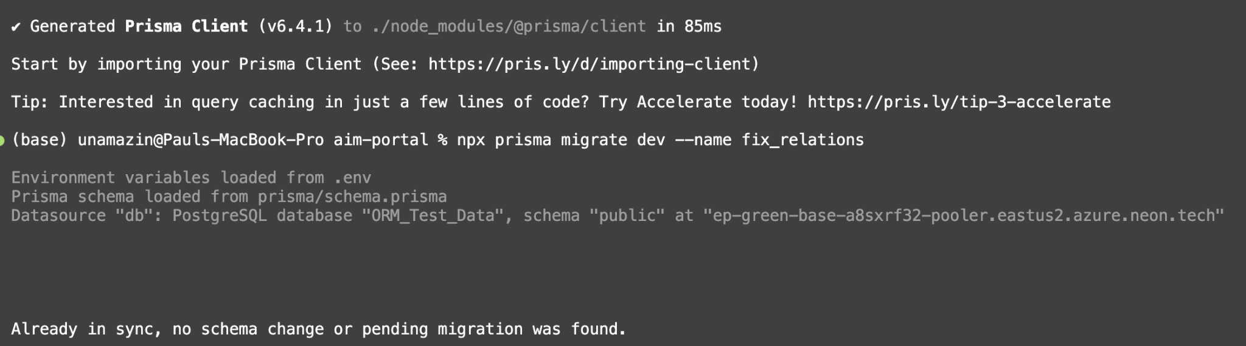

1. What problems did you run into? What is your plan for them?

Prisma setup with Neon was extremely tedious, with TONs of errors popping up. I also had to install several dependencies, and they somewhat clash with our current dependencies. I have no plan for this other than to document the changes made and then maybe downgrade our prisma if the dependencies screw the thing up.

1. What is the current overall project status from your perspective?

Our first sprint is (mostly) done. Good progress

1. How is your team functioning from your perspective?

We are communicating a lot more, and we are getting work done.

1. What new ideas did you have or skills did you develop this week?

I learned what an ORM is and i learned how to use prisma

1. Who was your most awesome team member this week and why?

Probably Shreyas. Shreyas made sure to communicate with all team members to make sure we were all on the same page, and identified potential issues and inefficiencies with our proposed implementation that we changed quickly.

| **Plans for Next Week** |
| --- |

What are you going to work on this next week?

I will work on creating all of the database stuff, and I will create the staff settings view.